FUTURE OF MOBILE COMMUNICATION :6G AND BEYOND

E.GPRADEEP RA2211004050026 21ECE421T

OPEN ENDED ASSIGNMENT

STATE OF MOBILE COMMUNICATION IN 5G TECHNOLOGY

The current state of mobile communication is dominated by the deployment of 5G technology, which provides faster speeds, lower latency, and better connectivity compared to previous generations. 5G networks use technologies like massive MIMO, beam forming, and millimeter-wave frequencies to offer higher data rates and support applications such as seamless video streaming, cloud gaming, and smart city solutions. These networks are also transforming industries by enabling Internet of Things (IOT) devices, supporting remote healthcare, and advancing autonomous vehicle development. However, the limitations of 5G, such as signal interference at high frequencies and limited coverage areas, highlight the need for further advancements. Research is now shifting towards higher frequencies, particularly those above 100 GHz, to address these challenges and unlock even greater potential. These unexplored frequency bands promise vast new spectrum opportunities that could support the next generation of mobile networks, like 6G. Future wireless systems aim to provide even more precise location tracking, advanced sensing capabilities, and high-speed communication over long distances. Efforts are being made to simplify signal processing and improve antenna designs to overcome issues like air-induced signal loss. 5G serves as a stepping stone toward these new technologies, but research in higher frequencies, including terahertz (THz) bands, will be critical to meeting the growing demand for faster and more reliable communication in the future.

5G TECHNOLOGY USER CASES:

5G technology is being deployed globally across various sectors, transforming industries with its high-speed connectivity, low latency, and massive device-handling capabilities. In telecommunications, 5G enhances mobile broadband, enabling faster streaming, gaming, and video conferencing. It supports smart city initiatives by enabling real-time monitoring of traffic, public safety systems, and environmental sensors. In healthcare, 5G powers remote surgeries, telemedicine, and wearable devices for continuous health monitoring, providing reliable and instant communication between patients and doctors. The automotive industry benefits from 5G with the development of autonomous vehicles and vehicle-to-everything (V2X) communication, improving road safety and traffic management. In manufacturing, 5G enables the Industrial Internet of Things (IIoT), automating processes with smart sensors, robots, and predictive maintenance systems. It also enhances logistics and supply chain operations by providing real-time tracking and monitoring of goods. In entertainment, 5G is revolutionizing augmented reality (AR) and virtual reality (VR) experiences, creating immersive content for gaming and events. Furthermore, it supports rural connectivity efforts by bridging the digital divide through high-speed wireless broadband. Across sectors, 5G facilitates energy management with smart grids and enhances agriculture with precision farming tools, marking a significant leap in global technological advancement.

MOVING TO 5G :

Atmospheric absorption plays a crucial role in the transmission of high-frequency signals, particularly in the context of 5G and beyond. Below 6 GHz, molecular absorption is minimal, but higher frequencies, such as those used in mmWave and THz bands, encounter significant challenges. Mie scattering becomes prominent as signal wavelengths approach the size of rain, snow, or dust particles, causing noticeable attenuation. Additionally, gases like oxygen and water vapor resonate at specific frequencies (e.g., 183 GHz, 325 GHz, and 760 GHz), leading to high signal losses. Despite this, the attenuation in certain mmWave bands (e.g., 28 GHz and 73 GHz) remains manageable, making them suitable for 5G mobile networks with small cells, typically within a 200-meter radius.

High-gain phased array antennas with beamforming capabilities are essential to overcome path losses at these frequencies. Notably, rain attenuation remains stable beyond 100 GHz, with moderate rainfall causing about 10 dB/km attenuation even at 1 THz, which can be compensated with increased antenna gain. Small-cell architectures, combined with adaptive beam steering and electronically steerable arrays, enable precise signal targeting and reduce blockage issues in dense urban environments. Using directional antennas at both ends, the effective path loss decreases as frequency increases, improving transmission efficiency. This supports the deployment of 5G and future 6G networks with ultra-high data rates and low latency, even at frequencies beyond 300 GHz. With reduced interference due to atmospheric absorption, these high-frequency bands are ideal for applications requiring massive bandwidth, such as ultra-fast backhaul links and automotive imaging radar, ensuring robust wireless communication despite environmental challenges.

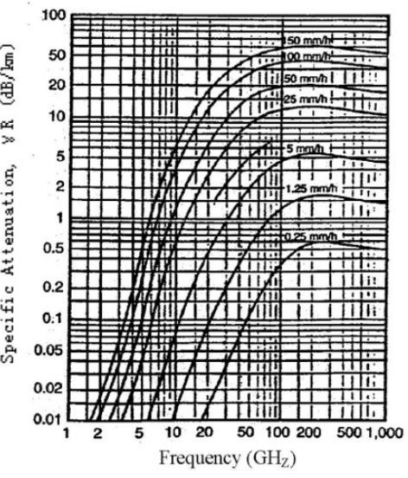 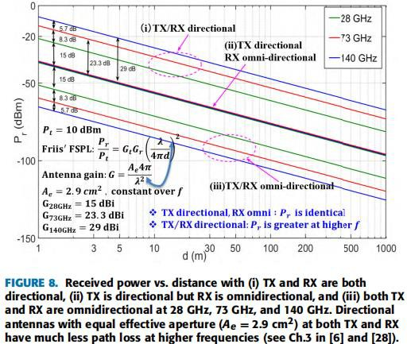

EMERGING TRENDS AND TECHNOLOGIES IN 6G:

6G technology is the next generation of wireless communication, expected to offer unprecedented data speeds, ultra- low latency, and intelligent network capabilities beyond what 5G provides. Operating in higher frequency bands, including millimeter-wave and terahertz (THz) ranges, 6G aims to achieve data rates up to 1 terabit per second (Tbps) and seamless connectivity over shorter distances. It will leverage advanced technologies like artificial intelligence (AI) and machine learning (ML) to optimize network performance, support real-time decision-making, and enable autonomous operations. With the integration of edge computing and reconfigurable intelligent surfaces (RIS), 6G networks will enhance signal coverage and energy efficiency. This technology will play a crucial role in advancing applications like holographic communication, extended reality (XR), autonomous vehicles, and smart infrastructure. 6G also emphasizes sustainability, focusing on green communication practices to reduce the environmental impact of network operations. Additionally, ultra-dense networks with small cells will ensure consistent and reliable connectivity in urban and remote areas. By 2030, 6G aims to create a more interconnected world, enabling breakthroughs in areas like telemedicine, precision agriculture, space communication, and Industry 4.0, driving the next wave of digital transformation and innovation.

PROMISING APPLICATIONS OF 6G:

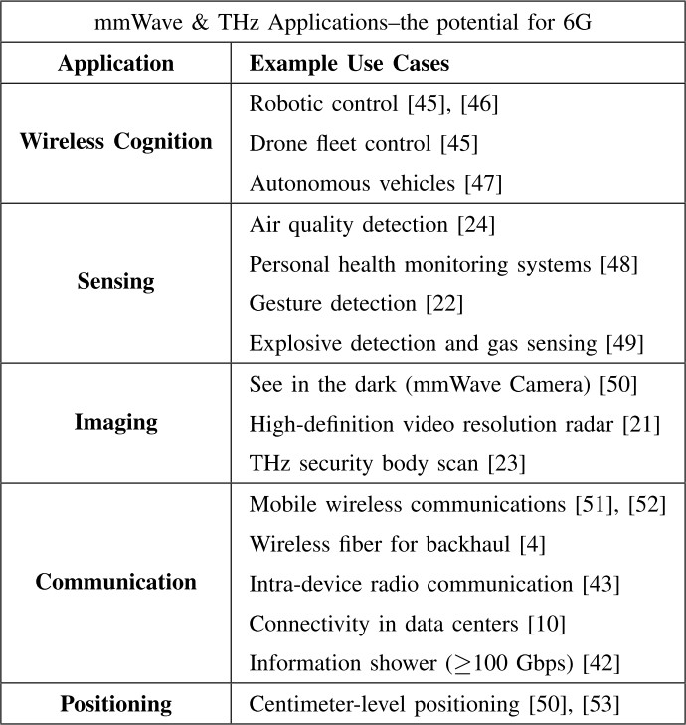

CHALLENGES OF USING 6G:

One major challenge of 6G is managing the vast data rates of up to 1 terabit per second (Tbps). Handling such speeds requires highly efficient infrastructure, including advanced antennas, terahertz (THz) frequency components, and ultra-fast processors. However, higher frequencies are more vulnerable to atmospheric absorption, rain, and obstacles, limiting transmission range and requiring line-of-sight or dense networks of small cells. Another issue is heat generation, as devices processing massive data at such speeds will require innovative cooling solutions.

For example, in a lab experiment transmitting 1 Tbps over a 100-meter link using THz waves, researchers observed that precise beam alignment was critical, and even slight misalignments caused signal loss. This highlights the need for advanced beamforming and electronically steerable antennas to maintain stable links. Additionally, the experiment faced challenges with power consumption, as maintaining high-speed transmission over long durations demanded significant energy.

Network security is also a concern, as ultra-fast data speeds could increase the risk of attacks if not managed properly. Developing reliable, low-latency encryption methods is essential to maintain secure communications. Overcoming these challenges will require breakthroughs in materials, antenna design, and AI-driven network management for efficient operations.

Development and deployment of 6G:

The development and deployment of 6G offer immense opportunities across industries. With speeds up to 1 terabit per second (Tbps) and ultra-low latency, 6G will unlock seamless connectivity for smart cities, autonomous vehicles, and advanced healthcare, enabling real-time remote surgeries and precision treatments. The integration of artificial intelligence (AI) with 6G networks will enhance decision-making, automate industries, and optimize traffic and energy systems.

Extended reality (XR), including virtual and augmented reality (VR/AR), will become more immersive, supporting applications like virtual tourism, education, and remote work. 6G’s ability to connect billions of devices efficiently will accelerate the Internet of Things (IoT), making homes, factories, and cities smarter. In space communications,

6G will offer reliable links between satellites, drones, and ground stations, improving global coverage and emergency response systems.

Additionally, 6G will enable digital twins—virtual models of real-world objects—used to predict failures in industries like manufacturing and aviation. The improved energy efficiency of 6G networks can also contribute to sustainable development by reducing carbon footprints. Overall, 6G has the potential to transform economies and daily life by enhancing connectivity and enabling new innovations.

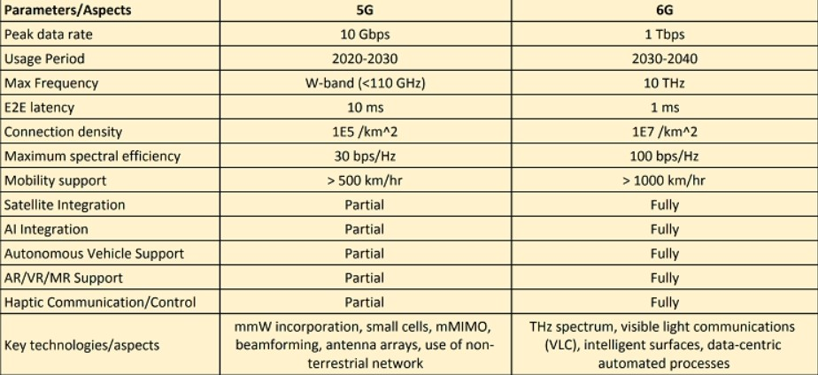

6G TECHNOLOGY IN HEALTHCARE INDUSTRIES:

6G technology has the potential to revolutionize healthcare in India by enabling advanced, efficient, and accessible medical services. With ultra-fast speeds, low latency, and enhanced connectivity, 6G will support real-time remote consultations, diagnostics, and surgeries, even in rural and remote areas. Doctors and specialists will be able to use extended reality (XR) tools like augmented and virtual reality (AR/VR) to guide complex medical procedures remotely, making quality care accessible across the country.

The integration of 6G with AI-powered health systems will enable faster data analysis for early disease detection, personalized treatments, and predictive healthcare models. Wearable devices connected through 6G will allow continuous patient monitoring, alerting doctors in case of emergencies such as heart attacks or diabetic crises, and helping manage chronic conditions more effectively.

6G will also enhance telemedicine services, improving doctor-patient interactions with seamless video and data transmissions, bridging the healthcare gap between urban and rural populations. Additionally, the use of digital twins—virtual models of patients—can aid in testing treatments before real-life application, improving outcomes.

Robotics, supported by 6G networks, will see greater adoption in healthcare, automating surgeries and assisting with elderly care. 6G’s ability to connect hospitals, laboratories, and pharmaceutical units will streamline drug research, manufacturing, and distribution. Overall, 6G has the potential to address India's healthcare challenges by promoting equitable access, improving outcomes, and boosting efficiency in medical services.

6G TECHNOLOGY IN TRANSPORTATION INDUSTRIES:

6G technology is set to transform India’s transportation sector by enabling smarter, safer, and more efficient mobility systems. With ultra-low latency, high-speed data transfer, and enhanced connectivity, 6G will support real-time monitoring and communication across transportation networks. This will enhance the performance of smart traffic management systems, helping reduce congestion, optimize traffic flow, and improve road safety.

In the railways and public transport sector, 6G will enable seamless communication between trains, stations, and control centers, ensuring better scheduling, fewer delays, and enhanced passenger experiences. Autonomous and connected vehicles will benefit greatly from 6G, as it provides the high-speed, low-latency communication needed for vehicle-to-vehicle (V2V) and vehicle-to-infrastructure (V2I) systems, promoting safer driving and preventing accidents.Drone delivery services, logistics tracking, and fleet management will also become more efficient with 6G, as real-time tracking and predictive analytics will optimize supply chains. Ports, airports, and freight hubs will use 6G-enabled IoT sensors for monitoring cargo conditions, automating operations, and improving turnaround times. Additionally, 6G will enhance public safety by enabling smart surveillance systems and emergency response solutions through instant data exchange between law enforcement agencies and transport authorities. Passengers on the go will experience faster, uninterrupted connectivity for infotainment and communication services.

Overall, 6G technology will empower India’s transportation industry by improving efficiency, safety, sustainability, and passenger satisfaction, playing a key role in the country’s smart mobility initiatives and infrastructure development.

6G TECHNOLOGY IN ENTERTAINMENT:

6G technology is poised to revolutionize India’s entertainment industry by offering ultra-fast connectivity, immersive experiences, and seamless content delivery. With speeds up to 1 Tbps and near-zero latency, streaming high-definition (8K or beyond) videos and live broadcasts will become instantaneous, enhancing viewer experience across platforms. Cloud-based gaming will see a major boost, allowing gamers to access high-quality, lag-free gameplay without expensive hardware, as 6G supports real-time rendering and edge computing.

Augmented Reality (AR), Virtual Reality (VR), and Mixed Reality (MR) will become more accessible, transforming live events, concerts, and sports experiences by enabling immersive participation from remote locations. Viewers can engage in virtual environments or use interactive features, enhancing engagement beyond traditional screens.

Metaverse applications, powered by 6G, will redefine entertainment by creating virtual spaces for social interaction, concerts, and gaming worlds, where users can participate in real-time.

For content creators, 6G will streamline production processes through advanced AI and remote collaboration tools, enabling efficient video editing, virtual shoots, and real-time feedback. Personalized content delivery will also improve with AI-driven analytics, offering customized recommendations and experiences based on user preferences. India’s film and music industries will benefit from faster distribution networks, reducing piracy and ensuring secure, high-speed releases across platforms. Additionally, 6G-enabled IoT sensors will enhance smart cinemas and venues, optimizing crowd management and improving viewer comfort. Overall, 6G technology will bring unprecedented changes to entertainment, creating new business models, immersive experiences, and enhanced content consumption across India.

Optimizing High-Frequency Wireless Communication for 6G Using AI and Advanced Technologies

Artificial Intelligence (AI), Machine Learning (ML), and other advanced technologies will play a transformative role in enhancing mobile communication, particularly in wireless systems operating above 100 GHz for 6G and beyond. These frequencies promise ultra-fast data rates and low latency, but they introduce challenges like signal attenuation, blockages, and complex propagation environments. AI and ML algorithms will optimize network operations by enabling intelligent beamforming, adaptive modulation, and dynamic resource allocation to maintain reliable connections despite high-frequency limitations.

AI-powered transceivers will enhance real-time decision-making, allowing networks to predict and adapt to changing conditions, such as user mobility or interference. Advanced ML models will manage large-scale antenna arrays required for high-frequency communication, improving energy efficiency and minimizing latency through optimized signal processing. AI-based predictive analytics will enhance spectrum sharing and interference management, ensuring efficient use of available bandwidth.

Technologies like edge computing and federated learning will reduce dependency on centralized systems, processing data locally to support ultra-reliable communication. Additionally, AI-enabled cybersecurity mechanisms will safeguard high-frequency networks against potential attacks by identifying anomalies in real time. These technologies will also improve Quality of Service (QoS) by predicting network traffic patterns and proactively resolving bottlenecks.

Overall, AI, ML, and other innovations will help overcome the challenges of high-frequency communication, ensuring efficient, adaptive, and secure networks that support the massive data demands of 6G applications like immersive experiences, IoT networks, and autonomous systems.

Artificial Intelligence (AI), Machine Learning (ML), and advanced technologies are crucial for enhancing wireless communication above 100 GHz, addressing the unique challenges these frequencies present for 6G and beyond. As signals at such high frequencies suffer from attenuation, blockages, and require precise line-of-sight, AI-driven algorithms enable dynamic beamforming and adaptive beam steering to maintain reliable connectivity even in complex environments. ML models optimize resource management, dynamically allocating spectrum and power to improve energy efficiency and reduce network congestion.

Predictive analytics powered by AI help anticipate user mobility and network traffic patterns, enabling seamless handovers and minimizing latency. Additionally, advanced technologies such as edge computing bring processing closer to the user, reducing dependence on central nodes and supporting ultra-reliable low-latency communication (URLLC). Federated learning enables decentralized data processing without compromising privacy, which is essential for secure, real-time communication in applications like autonomous vehicles and smart cities.

AI-based cybersecurity systems will monitor and respond to potential threats in real-time, safeguarding networks from malicious attacks. Furthermore, intelligent signal processing algorithms ensure the efficient management of large antenna arrays needed for high-frequency transmissions, improving signal quality and minimizing interference. These technologies collectively address the challenges of wireless communication beyond 100 GHz, enabling the deployment of high-capacity, low-latency networks that can support next-generation applications like immersive virtual reality (VR), massive IoT ecosystems, and ultra-fast mobile broadband.